-----------------------------------------------Steps to install the CN and gNB---------------------------------------------
->https://hackmd.io/@praveeng/6GMLAB-OAI-5G-SETUP-GUIDE#OAI-5G-SA-Setup-Guide
->https://gitlab.eurecom.fr/oai/openairinterface5g/-/blob/c5aeaf03dc9d50bc46a9955e97b0556261f359fd/doc/NR_SA_Tutorial_COTS_UE.md#32-build-oai-gnb
OS - ubuntu 22.04 LTS

Before even installing we must install the following pre-requisites-----

1) Low latency Kernel---
sudo apt update
sudo apt install -y linux-lowlatency
uname -r

output:- 5.15.0-*-lowlatency

2) Set CPU C-State and Disable P-State in GRUB
sudo nano /etc/default/grub
- in that change only the below lines from
GRUB_CMDLINE_LINUX_DEFAULT="quiet splash"

to -
GRUB_CMDLINE_LINUX_DEFAULT="quiet splash intel_pstate=disable processor.max_cstate=1 idle=poll nosoftlockup"

then ctrl+o -> Enter -> ctrl+x

then -
sudo update-grub
sudo reboot
to verify--
cat /proc/cmdline

3) Blacklist intel_powerclamp module
sudo bash -c 'echo "blacklist intel_powerclamp" >> /etc/modprobe.d/blacklist.conf'
sudo update-initramfs -u
sudo reboot

then verify if its not loaded , when enter the below command you should not get anything-
lsmod | grep intel_powerclamp

4) Disable Hyper-Threading
In BIOS - Hyper-Threading = Disabled

5) Disable CPU Frequency Scaling (Governor to “performance”)
for CPUFREQ in /sys/devices/system/cpu/cpu*/cpufreq/scaling_governor; do
echo performance | sudo tee $CPUFREQ
done

To make it persistent after reboot:----------
sudo apt install -y cpufrequtils
echo 'GOVERNOR="performance"' | sudo tee /etc/default/cpufrequtils
sudo systemctl enable cpufrequtils

6) Disable Power Management and Turbo in BIOS
in BIOS - Disable Intel SpeedStep (EIST)
Disable C-States (all)
Disable Turbo Mode
Set Power Management → Maximum Performance

7) Verify Your Real-Time System
cat /sys/devices/system/cpu/cpu*/cpufreq/scaling_governor

output-it should say PERFORMANCE

8) Install i7z utility to check the cpu-
sudo apt-get install i7z
sudo i7z

9) Install cpufrequtils:
sudo apt-get install cpufrequtils
sudo nano /etc/default/cpufrequtils
----then add this line-----GOVERNOR="performance"

then save and exit(ctrl+o -> Enter -> ctrl+x)

-----------------------------------------------OAI CN PC installation---------------------------------------------

1) Install Docker Engine and enable it--
sudo apt update
sudo apt install -y docker.io
sudo systemctl enable --now docker

verify-

docker --version
sudo systemctl status docker | grep Active

Expected: active (running)

2) Install Docker Compose plugin-
sudo apt install -y docker-compose

verify-
docker-compose version

Expected-.
version ≥ 1.29

3) Enable IP forwarding permanently-
# enable immediately
sudo sysctl -w net.ipv4.ip_forward=1

# make persistent
echo "net.ipv4.ip_forward=1" | sudo tee -a /etc/sysctl.conf
sudo sysctl -p

verify----
cat /proc/sys/net/ipv4/ip_forward

4) Quick re-check
docker --version
docker-compose version
cat /proc/sys/net/ipv4/ip_forward

----------------------------Installing OAI CN---------------------------

1) Clean start (optional but safe)
cd ~
sudo rm -rf oai-cn5g-fed
docker system prune -af

2) Clone the OAI CN5G repository
cd ~
git clone https://gitlab.eurecom.fr/oai/cn5g/oai-cn5g-fed.git
cd oai-cn5g-fed/docker-compose

3) Pull / fetch required Docker images
docker-compose -f docker-compose-basic-nrf.yaml pull

-------------then open oai-cn5g-fed/docker-compose/docker-compose-basic-nrf.yaml-------------(uncomment every CN Container's IP and do changes in oai-amf (already done below))

version: '3.8'
services:
mysql:
container_name: "mysql"
image: mysql:8.0
volumes:
- ./database/oai_db2.sql:/docker-entrypoint-initdb.d/oai_db.sql
- ./healthscripts/mysql-healthcheck2.sh:/tmp/mysql-healthcheck.sh
environment:
- TZ=Europe/Paris
- MYSQL_DATABASE=oai_db
- MYSQL_USER=test
- MYSQL_PASSWORD=test
- MYSQL_ROOT_PASSWORD=linux
healthcheck:
test: /bin/bash -c "/tmp/mysql-healthcheck.sh"
interval: 10s
timeout: 5s
retries: 30
networks:
public_net:
# For CI purposes, we are keeping the line commented
ipv4_address: 192.168.70.131
oai-udr:
container_name: "oai-udr"
image: oaisoftwarealliance/oai-udr:v2.1.0
expose:
- 80/tcp
- 8080/tcp
volumes:
- ./conf/basic_nrf_config.yaml:/openair-udr/etc/config.yaml
environment:
- TZ=Europe/Paris
depends_on:
- mysql
- oai-nrf
networks:
public_net:
# For CI purposes, we are keeping the line commented
ipv4_address: 192.168.70.136
oai-udm:
container_name: "oai-udm"
image: oaisoftwarealliance/oai-udm:v2.1.0
expose:
- 80/tcp
- 8080/tcp
volumes:
- ./conf/basic_nrf_config.yaml:/openair-udm/etc/config.yaml
environment:
- TZ=Europe/Paris
depends_on:
- oai-nrf
networks:
public_net:
# For CI purposes, we are keeping the line commented
ipv4_address: 192.168.70.137
oai-ausf:
container_name: "oai-ausf"
image: oaisoftwarealliance/oai-ausf:v2.1.0
expose:
- 80/tcp
- 8080/tcp
volumes:
- ./conf/basic_nrf_config.yaml:/openair-ausf/etc/config.yaml
environment:
- TZ=Europe/Paris
depends_on:
- oai-nrf
networks:
public_net:
# For CI purposes, we are keeping the line commented
ipv4_address: 192.168.70.138
oai-nrf:
container_name: "oai-nrf"
image: oaisoftwarealliance/oai-nrf:v2.1.0
expose:
- 80/tcp
- 8080/tcp
volumes:
- ./conf/basic_nrf_config.yaml:/openair-nrf/etc/config.yaml
environment:
- TZ=Europe/Paris
networks:
public_net:
# For CI purposes, we are keeping the line commented
ipv4_address: 192.168.70.130
oai-amf:
container_name: "oai-amf"
image: oaisoftwarealliance/oai-amf:v2.1.0
expose:
- 80/tcp
- 8080/tcp
- 38412/sctp
ports:
- "38412:38412/sctp"
volumes:
- ./conf/basic_nrf_config.yaml:/openair-amf/etc/config.yaml
environment:
- TZ=Europe/Paris
depends_on:
- oai-nrf
networks:
public_net:
# For CI purposes, we are keeping the line commented
ipv4_address: 192.168.70.132
oai-smf:
container_name: "oai-smf"
image: oaisoftwarealliance/oai-smf:v2.1.0
expose:
- 80/tcp
- 8080/tcp
- 8805/udp
volumes:
- ./conf/basic_nrf_config.yaml:/openair-smf/etc/config.yaml
environment:
- TZ=Europe/Paris
depends_on:
- oai-nrf
networks:
public_net:
# For CI purposes, we are keeping the line commented
ipv4_address: 192.168.70.133
oai-upf:
container_name: "oai-upf"
image: oaisoftwarealliance/oai-upf:v2.1.0
expose:
- 2152/udp
- 8805/udp
volumes:
- ./conf/basic_nrf_config.yaml:/openair-upf/etc/config.yaml
environment:
- TZ=Europe/Paris
depends_on:
- oai-nrf
cap_add:
- NET_ADMIN
- SYS_ADMIN
cap_drop:
- ALL
privileged: true
networks:
public_net:
# For CI purposes, we are keeping the line commented
ipv4_address: 192.168.70.134
oai-ext-dn:
privileged: true
init: true
container_name: oai-ext-dn
image: oaisoftwarealliance/trf-gen-cn5g:latest
environment:
- UPF_FQDN=oai-upf
- UE_NETWORK=12.1.1.0/24
- USE_FQDN=yes
healthcheck:
test: /bin/bash -c "ip r | grep 12.1.1"
interval: 10s
timeout: 5s
retries: 5
networks:
public_net:
# For CI purposes, we are keeping the line commented
ipv4_address: 192.168.70.135

networks:
public_net:
driver: bridge
name: demo-oai-public-net
ipam:
config:
- subnet: 192.168.70.128/26
driver_opts:
com.docker.network.bridge.name: "demo-oai"

-----------------------------open oai-cn5g-fed/docker-compose/conf

################################################################################
# Licensed to the OpenAirInterface (OAI) Software Alliance under one or more
# contributor license agreements. See the NOTICE file distributed with
# this work for additional information regarding copyright ownership.
# The OpenAirInterface Software Alliance licenses this file to You under
# the OAI Public License, Version 1.1 (the "License"); you may not use this file
# except in compliance with the License.
# You may obtain a copy of the License at
#
# http://www.openairinterface.org/?page_id=698
#
# Unless required by applicable law or agreed to in writing, software
# distributed under the License is distributed on an "AS IS" BASIS,
# WITHOUT WARRANTIES OR CONDITIONS OF ANY KIND, either express or implied.
# See the License for the specific language governing permissions and
# limitations under the License.
#-------------------------------------------------------------------------------
# For more information about the OpenAirInterface (OAI) Software Alliance:
# contact@openairinterface.org
################################################################################

# OAI CN Configuration File
### This file can be used by all OAI NFs
### Some fields are specific to an NF and will be ignored by other NFs

## NOTE ON YAML ANCHORS ##
# We use YAML anchors to ease the configuration and to avoid duplicating parts of the configuration.
# This is especially true for the SNSSAIs, as we have to define them for multiple NFs.
# Please note that the use of anchors is not mandatory, and you can define the SNSSAI in each NF yourself.
# You can read more about anchors here: https://yaml.org/spec/1.2.2/#anchors-and-aliases

############# Common configuration

# Log level for all the NFs
log_level:
general: debug

# If you enable registration, the other NFs will use the NRF discovery mechanism
register_nf:
general: yes

http_version: 2

############## SBI Interfaces
### Each NF takes its local SBI interfaces and remote interfaces from here, unless it gets them using NRF discovery mechanisms
nfs:
amf:
host: oai-amf
sbi:
port: 8080
api_version: v1
interface_name: eth0
n2:
interface_name: eth0
port: 38412
smf:
host: oai-smf
sbi:
port: 8080
api_version: v1
interface_name: eth0
n4:
interface_name: eth0
port: 8805
upf:
host: oai-upf
sbi:
port: 8080
api_version: v1
interface_name: eth0
n3:
interface_name: eth0
port: 2152
n4:
interface_name: eth0
port: 8805
n6:
interface_name: eth0
n9:
interface_name: eth0
port: 2152
udm:
host: oai-udm
sbi:
port: 8080
api_version: v1
interface_name: eth0
udr:
host: oai-udr
sbi:
port: 8080
api_version: v1
interface_name: eth0
ausf:
host: oai-ausf
sbi:
port: 8080
api_version: v1
interface_name: eth0
nrf:
host: oai-nrf
sbi:
port: 8080
api_version: v1
interface_name: eth0

#### Common for UDR and AMF
database:
host: mysql
user: test
type: mysql
password: test
database_name: oai_db
generate_random: true
connection_timeout: 300 # seconds

## general single_nssai configuration
## Defines YAML anchors, which are reused in the config file
snssais:
- &embb_slice1
sst: 1
- &embb_slice2
sst: 1
sd: 000001 # in hex
- &custom_slice
sst: 222
sd: 00007B # in hex

############## NF-specific configuration
amf:
amf_name: "OAI-AMF"
# This really depends on if we want to keep the "mini" version or not
support_features_options:
enable_simple_scenario: no # "no" by default with the normal deployment scenarios with AMF/SMF/UPF/AUSF/UDM/UDR/NRF.
# set it to "yes" to use with the minimalist deployment scenario (including only AMF/SMF/UPF) by using the internal AUSF/UDM implemented inside AMF.
# There's no NRF in this scenario, SMF info is taken from "nfs" section.
enable_nssf: no
enable_smf_selection: yes
relative_capacity: 30
statistics_timer_interval: 20 # in seconds
emergency_support: false
served_guami_list:
- mcc: 001 # changed by me
mnc: 01 # changed by me
amf_region_id: 01
amf_set_id: 001
amf_pointer: 01
- mcc: 001 # changed by me
mnc: 01 # changed by me
amf_region_id: 01
amf_set_id: 001
amf_pointer: 01
plmn_support_list:
- mcc: 001
mnc: 01
tac: 1 # changed by me
nssai:
- *embb_slice1
- *embb_slice2
- *custom_slice
supported_integrity_algorithms:
- "NIA0"
- "NIA1"
- "NIA2"
supported_encryption_algorithms:
- "NEA0"
- "NEA1"
- "NEA2"

smf:
ue_mtu: 1500
support_features:
use_local_subscription_info: yes # Use infos from local_subscription_info or from UDM
use_local_pcc_rules: yes # Use infos from local_pcc_rules or from PCF
# we resolve from NRF, this is just to configure usage_reporting
upfs:
- host: oai-upf
config:
enable_usage_reporting: no
ue_dns:
primary_ipv4: "172.21.3.100"
primary_ipv6: "2001:4860:4860::8888"
secondary_ipv4: "8.8.8.8"
secondary_ipv6: "2001:4860:4860::8888"
ims:
pcscf_ipv4: "127.0.0.1"
pcscf_ipv6: "fe80::7915:f408:1787:db8b"
# the DNN you configure here should be configured in "dnns"
# follows the SmfInfo datatype from 3GPP TS 29.510
smf_info:
sNssaiSmfInfoList:
- sNssai: *embb_slice1
dnnSmfInfoList:
- dnn: "oai"
- sNssai: *embb_slice2
dnnSmfInfoList:
- dnn: "oai.ipv4"
- sNssai: *custom_slice
dnnSmfInfoList:
- dnn: "default"
local_subscription_infos:
- single_nssai: *embb_slice1
dnn: "oai"
qos_profile:
5qi: 9
session_ambr_ul: "200Mbps"
session_ambr_dl: "400Mbps"
- single_nssai: *embb_slice2
dnn: "oai.ipv4"
qos_profile:
5qi: 9
session_ambr_ul: "100Mbps"
session_ambr_dl: "200Mbps"
- single_nssai: *custom_slice
dnn: "default"
qos_profile:
5qi: 9
session_ambr_ul: "50Mbps"
session_ambr_dl: "100Mbps"

upf:
support_features:
enable_bpf_datapath: no # If "on": BPF is used as datapath else simpleswitch is used, DEFAULT= off
enable_snat: yes # If "on": Source natting is done for UE, DEFAULT= off
remote_n6_gw: localhost # Dummy host since simple-switch does not use N6 GW
smfs:
- host: oai-smf # To be used for PFCP association in case of no-NRF
upf_info:
sNssaiUpfInfoList:
- sNssai: *embb_slice1
dnnUpfInfoList:
- dnn: "oai"
- sNssai: *embb_slice2
dnnUpfInfoList:
- dnn: "oai.ipv4"
- sNssai: *custom_slice
dnnUpfInfoList:
- dnn: "default"

## DNN configuration
dnns:
- dnn: "oai"
pdu_session_type: "IPV4"
ipv4_subnet: "12.1.1.128/25"
- dnn: "oai.ipv4"
pdu_session_type: "IPV4"
ipv4_subnet: "12.1.1.64/26"
- dnn: "default"
pdu_session_type: "IPV4"
ipv4_subnet: "12.1.1.0/26"
- dnn: "ims"
pdu_session_type: "IPV4V6"
ipv4_subnet: "14.1.1.2/24"

---------------------------------------------------------how to run the CN------------------------------------

1) Start CN (simulation mode)
cd ~/oai-cn5g-fed/docker-compose
python3 core-network.py --type start-basic

2) Verify containers are running and healthy
docker ps --format "table {{.Names}}\t{{.Status}}\t{{.Ports}}"

Expected-
oai-nrf Up (healthy)
oai-amf Up (healthy)
oai-smf Up (healthy)
oai-upf Up (healthy)
oai-ausf Up (healthy)
oai-udm Up (healthy)
oai-udr Up (healthy)
mysql Up (healthy)

3) Check NRF Registration-
sudo apt install -y jq
curl -s -X GET --http2-prior-knowledge "http://192.168.70.130:8080/nnrf-nfm/v1/nf-instances?nf-type=NRF" | jq .
curl -s -X GET --http2-prior-knowledge "http://192.168.70.130:8080/nnrf-nfm/v1/nf-instances?nf-type=AMF" | jq .
curl -s -X GET --http2-prior-knowledge "http://192.168.70.130:8080/nnrf-nfm/v1/nf-instances?nf-type=SMF" | jq .
curl -s -X GET --http2-prior-knowledge "http://192.168.70.130:8080/nnrf-nfm/v1/nf-instances?nf-type=UPF" | jq .
curl -s -X GET --http2-prior-knowledge "http://192.168.70.130:8080/nnrf-nfm/v1/nf-instances?nf-type=UDM" | jq .
curl -s -X GET --http2-prior-knowledge "http://192.168.70.130:8080/nnrf-nfm/v1/nf-instances?nf-type=AUSF" | jq .

expected-----------------------
dtri@dtri-H510M-H:~/oai-cn5g-fed/docker-compose$ curl -s -X GET --http2-prior-knowledge "http://192.168.70.130:8080/nnrf-nfm/v1/nf-instances?nf-type=NRF" | jq .
{
"_links": {
"item": [],
"self": ""
}
}
dtri@dtri-H510M-H:~/oai-cn5g-fed/docker-compose$ curl -s -X GET --http2-prior-knowledge "http://192.168.70.130:8080/nnrf-nfm/v1/nf-instances?nf-type=AMF" | jq .
curl -s -X GET --http2-prior-knowledge "http://192.168.70.130:8080/nnrf-nfm/v1/nf-instances?nf-type=SMF" | jq .
curl -s -X GET --http2-prior-knowledge "http://192.168.70.130:8080/nnrf-nfm/v1/nf-instances?nf-type=UPF" | jq .
curl -s -X GET --http2-prior-knowledge "http://192.168.70.130:8080/nnrf-nfm/v1/nf-instances?nf-type=UDM" | jq .
curl -s -X GET --http2-prior-knowledge "http://192.168.70.130:8080/nnrf-nfm/v1/nf-instances?nf-type=AUSF" | jq .
{
"_links": {
"item": [
{
"href": "192.168.70.132"
}
],
"self": ""
}
}
{
"_links": {
"item": [
{
"href": "192.168.70.133"
}
],
"self": ""
}
}
{
"_links": {
"item": [
{
"href": "192.168.70.134"
}
],
"self": ""
}
}
{
"_links": {
"item": [
{
"href": "192.168.70.137"
}
],
"self": ""
}
}
{
"_links": {
"item": [
{
"href": "192.168.70.138"
}
],
"self": ""
}
}

4) Verify CN Readiness for gNB Connection
docker exec -it oai-amf bash
netstat -an | grep 38412

expected----
sctp LISTEN 0 5 0.0.0.0:38412

5) Then after running the gNB we should see in the CN PC that the gNB is connected-----

-docker logs oai-amf -f

the above command starts the heartbeat which refreshes and there in the table we must make sure that the gNB is visible and it shows connected

Pictures Just for reference----
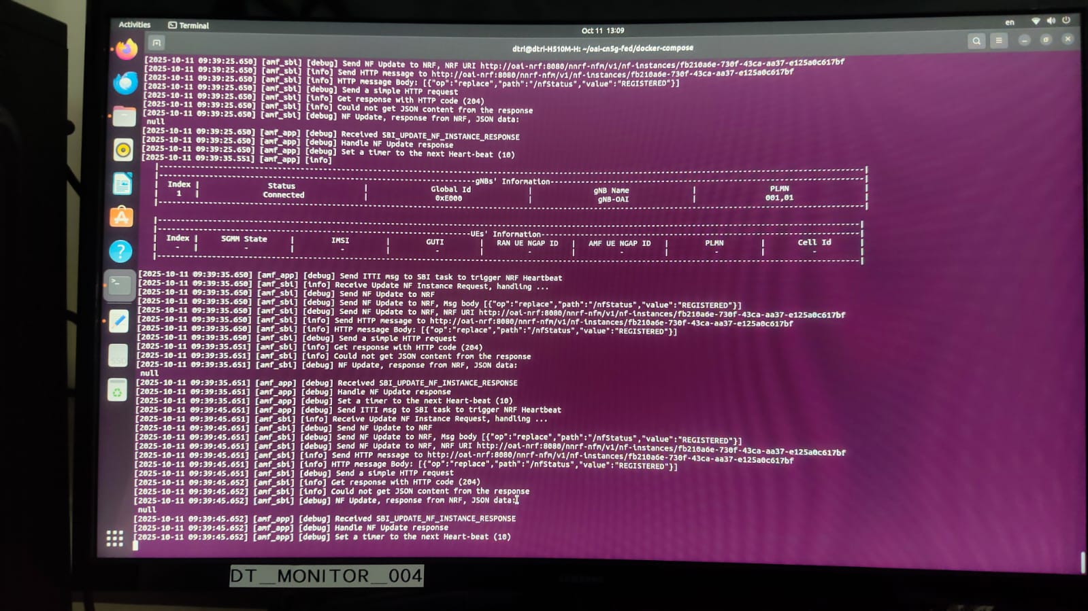

If the SCTP Link is established but not connected then it will show as below----
this happens because of some configuration error
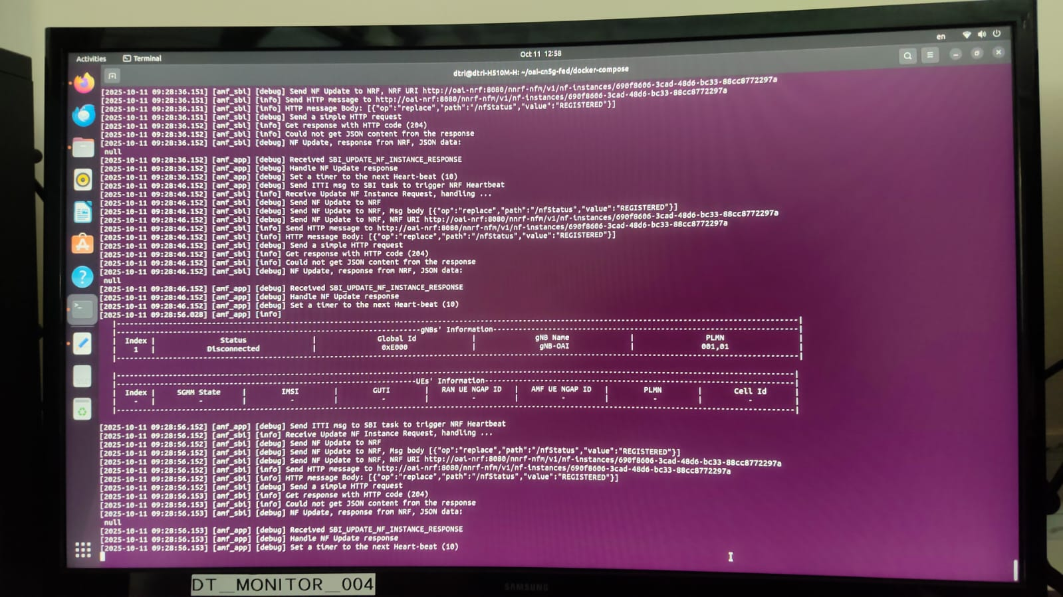
If the SCTP Link is only not established then u will get the table as blank
sometimes there wont be any error displaying but the table will be empty that means that the CN and gNB didn’t even establish the connection in the first place then the configuration might be not correct or incorrect IP configuration

